# Inspiration

Cybersecurity attacks are rapidly increasing in scale and complexity, affecting users, businesses, and governments globally. We built Cyber-Aware to visualize these threats on a world map and raise awareness through an engaging, educational interface that shows real-world cyberattacks, their impact, and how to defend against them.

# Overview

Cyber-Aware is an interactive web-based cyberattack visualization tool that:

* Displays real-world cyberattacks on a global map
* Provides detailed definitions and security tips for each attack type
* Supports various attack types like Ransomware, DDoS, Phishing, SQL Injection, and more
* Loads of dynamic data from a curated JSON dataset of over 60 authentic attack records
* Runs entirely in the browser using Google Maps API + HTML/CSS/JavaScript

# Tech-Stack

* Frontend: HTML5, CSS3 (glass morphism, responsive design), JavaScript (ES6+)
* APIs: Google Maps JavaScript API, Geocoding and Places API
* Data: Enhanced dataset based on real-world cybersecurity incidents.
* Deployment: GitHub Pages

# Challenges

* Verifying and structuring authentic cyberattack data
* Implementing smooth UI/UX animations using only vanilla technologies
* Ensuring accurate geolocation mapping and consistent data rendering

# Accomplishments

* Visualizing real-world cyber threats with educational context
* Built a highly interactive and responsive UI using glass morphism
* Fully hosted and deployed with zero dependencies

# Learning from the Project

* API integration
* Working with complex datasets and asynchronous fetch
* Creating professional UI with custom styling and animations
* Deploying clean, production-ready projects on GitHub Pages

# Future Enhancements

* Add real-time attack feeds from threat intelligence APIs
* Implement filters (by country, type, time)
* Add mobile-first support and accessibility improvements
* Introducing educational modules or gamified content

# Links

Live Demo

# Screenshots

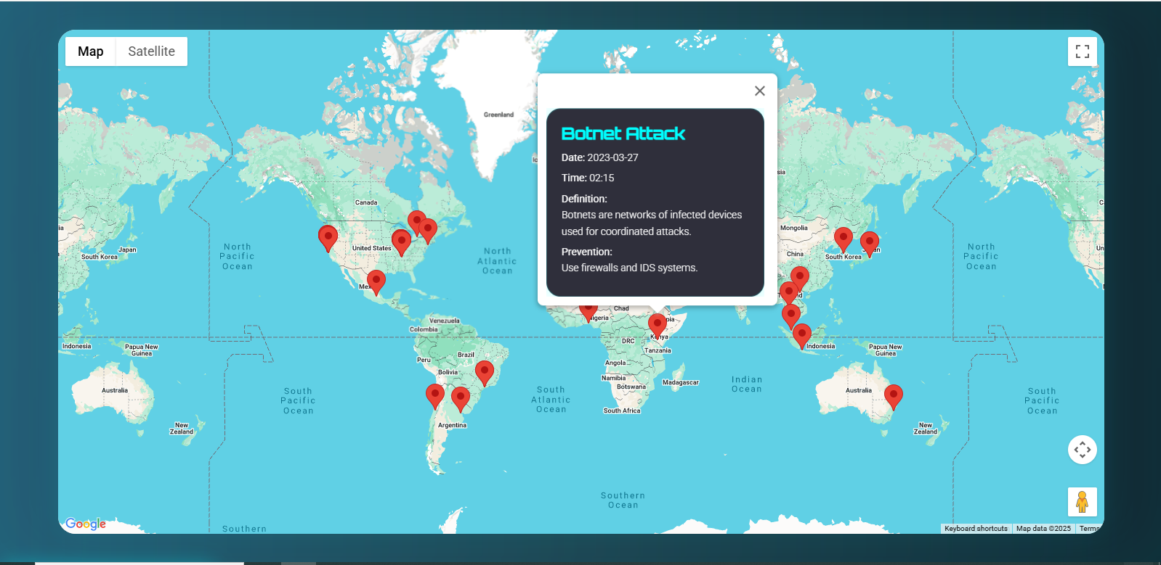

**Fig 1:** Map with markers indicating the areas affected with different types of attacks

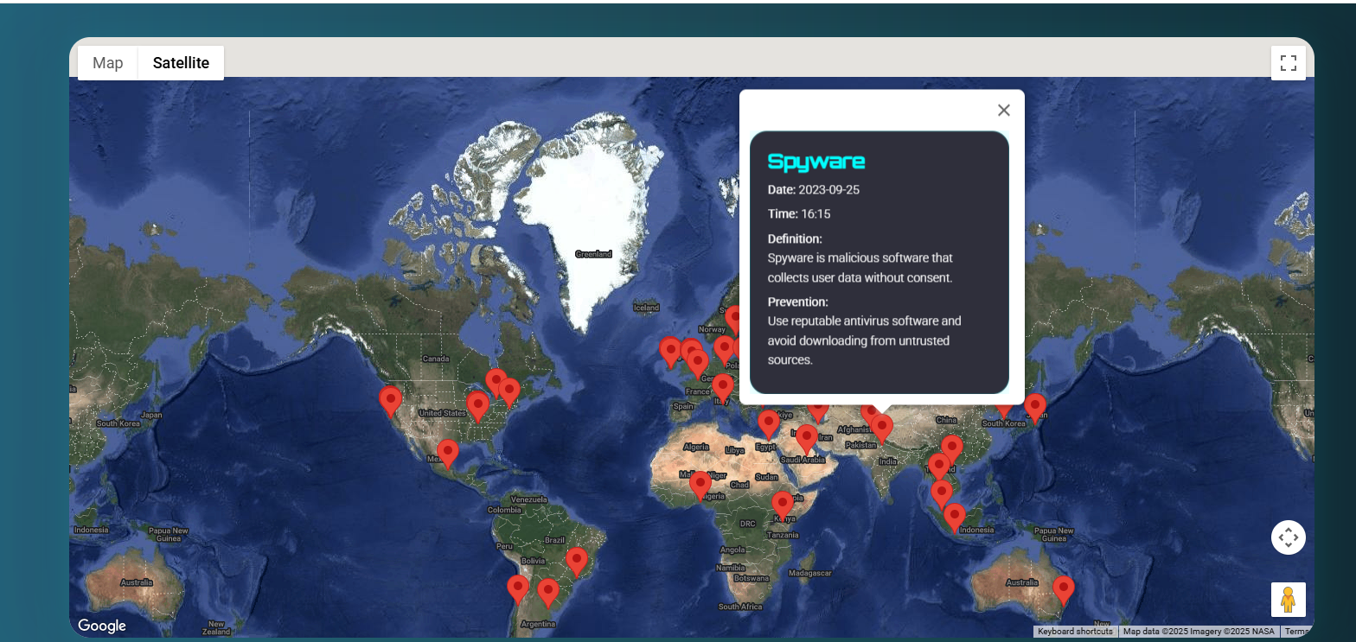

**Fig 2:** Satellite View